Arduino code:

#include <Servo.h>

// Define flame sensor pins
//#define FLAME_SENSOR_LEFT A0
#define FLAME_SENSOR_CENTER A1
//#define FLAME_SENSOR_RIGHT A2

// Define motor driver pins
#define MOTOR_L1 5 // Left Motor Forward
#define MOTOR_L2 6 // Left Motor Backward
#define MOTOR_R1 9 // Right Motor Forward
#define MOTOR_R2 10 // Right Motor Backward

// Define relay for water pump
#define RELAY_PIN 7
#define RELAY_ON LOW // active-LOW module: LOW energizes the relay
#define RELAY_OFF HIGH // HIGH releases the relay

// Define servo motor pin
#define SERVO_PIN 3

// Create Servo object
Servo waterServo;

// Flame sensor threshold
#define FIRE_DETECTED_THRESHOLD 800 // Adjust based on sensor readings

void setup() {
// Initialize Serial Monitor
Serial.begin(9600);

// Set motor pins as output
pinMode(MOTOR_L1, OUTPUT);
pinMode(MOTOR_L2, OUTPUT);
pinMode(MOTOR_R1, OUTPUT);
pinMode(MOTOR_R2, OUTPUT);

// Set relay as output
pinMode(RELAY_PIN, OUTPUT);
digitalWrite(RELAY_PIN, RELAY_OFF); // make sure it's OFF at boot

// Initialize servo motor
waterServo.attach(SERVO_PIN);
waterServo.write(90); // Set initial servo position to center

// Set flame sensor pins as input
//pinMode(FLAME_SENSOR_LEFT, INPUT);
pinMode(FLAME_SENSOR_CENTER, INPUT);
//pinMode(FLAME_SENSOR_RIGHT, INPUT);

Serial.println("🚀 Fire Fighting Robot Initialized...");
}

void loop() {
// Read flame sensor values
//int flameLeft = analogRead(FLAME_SENSOR_LEFT);
int flameCenter = analogRead(FLAME_SENSOR_CENTER);
//int flameRight = analogRead(FLAME_SENSOR_RIGHT);

// Print sensor values to Serial Monitor
// Serial.print("Flame Left: ");
// Serial.print(flameLeft);
Serial.print(" | Flame Center: ");
Serial.print(flameCenter);
// Serial.print(" | Flame Right: ");
// Serial.println(flameRight);

// Check flame detection
if (flameCenter < FIRE_DETECTED_THRESHOLD) {
Serial.println("🔥 Fire Detected at Center! Moving Forward...");
moveForward();
activateWaterPump();
}
// else if (flameLeft < FIRE_DETECTED_THRESHOLD) {
// Serial.println("🔥 Fire Detected at Left! Turning Left...");
// turnLeft();
// activateWaterPump();
// }
// else if (flameRight < FIRE_DETECTED_THRESHOLD) {
// Serial.println("🔥 Fire Detected at Right! Turning Right...");
// turnRight();
// activateWaterPump();
// }
else {
Serial.println("✅ No Fire Detected. Stopping...");
stopMotors();
deactivateWaterPump(); // Ensure pump is OFF when no fire is detected
}

delay(500); // Delay for stability
}

// Function to move forward
void moveForward() {
digitalWrite(MOTOR_L1, HIGH);
digitalWrite(MOTOR_L2, LOW);
digitalWrite(MOTOR_R1, HIGH);
digitalWrite(MOTOR_R2, LOW);
}

// Function to turn left
// void turnLeft() {
// digitalWrite(MOTOR_L1, LOW);
// digitalWrite(MOTOR_L2, HIGH);
// digitalWrite(MOTOR_R1, HIGH);
// digitalWrite(MOTOR_R2, LOW);
// delay(500); // Adjust timing
// stopMotors();
// }

// // Function to turn right
// void turnRight() {
// digitalWrite(MOTOR_L1, HIGH);
// digitalWrite(MOTOR_L2, LOW);
// digitalWrite(MOTOR_R1, LOW);
// digitalWrite(MOTOR_R2, HIGH);
// delay(500); // Adjust timing
// stopMotors();
// }

// Function to stop motors
void stopMotors() {
digitalWrite(MOTOR_L1, LOW);
digitalWrite(MOTOR_L2, LOW);
digitalWrite(MOTOR_R1, LOW);
digitalWrite(MOTOR_R2, LOW);
}

// Function to activate water pump and move servo
void activateWaterPump() {
Serial.println("🚰 Activating Water Pump...");
digitalWrite(RELAY_PIN, RELAY_ON); // energize relay

// Move the servo from left to right
for (int pos = 60; pos <= 120; pos += 5) {
waterServo.write(pos);
delay(100);
}

// Move the servo from right to left
for (int pos = 120; pos >= 60; pos -= 5) {
waterServo.write(pos);
delay(100);
}

delay(2000); // Pump stays on for 2 seconds
deactivateWaterPump(); // Turn off the water pump
}

// Function to deactivate water pump
void deactivateWaterPump() {
Serial.println("✅ Deactivating Water Pump...");
digitalWrite(RELAY_PIN, RELAY_OFF); // Turn OFF the water pump
waterServo.write(90); // Reset servo to center position
}

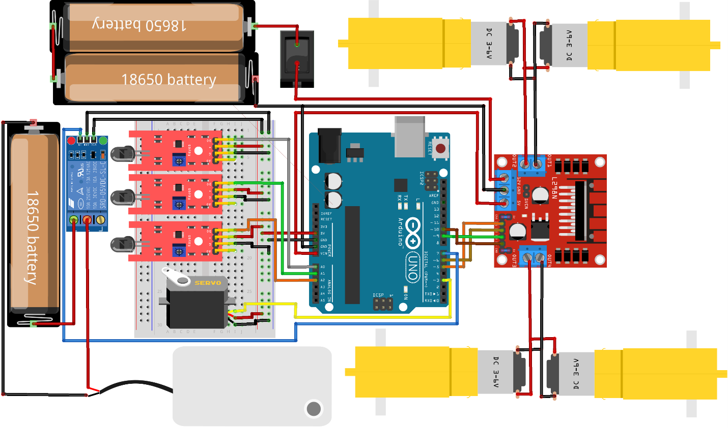

Nodemcu code:
#include <ESP8266WiFi.h>
#include <WiFiClientSecure.h>

// ---- WiFi & Telegram ----
const char* ssid = "Hamim";
const char* password = "naim1526";
String BOTtoken = "7088853958:AAHj0BK5aPeBAjPShUygN_6UkBr35v7HBII";
String chat_id = "8130473653";

// ---- Hardware ----
#define FLAME_PIN A0
#define FLAME_THRESHOLD 300 // Fire if value goes below this
#define HYSTERESIS 50 // Reset margin

WiFiClientSecure client;
bool flameLatched = false; // prevents spamming

// ---- Helpers ----
String urlencode(const String& str) {
String enc = "";
for (uint16_t i = 0; i < str.length(); i++) {
char c = str[i];
if (c == ' ') enc += '+';
else if (isalnum(c)) enc += c;
else {
char hex1 = (c >> 4) & 0xF, hex2 = c & 0xF;
enc += '%';
enc += char(hex1 < 10 ? '0' + hex1 : 'A' + (hex1 - 10));
enc += char(hex2 < 10 ? '0' + hex2 : 'A' + (hex2 - 10));
}
}
return enc;
}

void sendTelegram(const String& msg) {
if (WiFi.status() != WL_CONNECTED) return;
if (!client.connect("api.telegram.org", 443)) {
Serial.println("Telegram connect failed");
return;
}
String url = "/bot" + BOTtoken + "/sendMessage?chat_id=" + chat_id +
"&text=" + urlencode(msg);
client.print(String("GET ") + url + " HTTP/1.1\r\n" +
"Host: api.telegram.org\r\n" +
"Connection: close\r\n\r\n");
Serial.println("Telegram sent: " + msg);
}

void setup() {
Serial.begin(115200);
delay(200);

// Wi-Fi
WiFi.mode(WIFI_STA);
WiFi.begin(ssid, password);
Serial.print("Connecting");
while (WiFi.status() != WL_CONNECTED) { delay(300); Serial.print("."); }
Serial.println("\nConnected: " + WiFi.localIP().toString());

client.setInsecure(); // skip certificate check
}

void loop() {
int v = analogRead(FLAME_PIN);
Serial.print("Flame value: "); Serial.println(v);

bool fireDetected = (v < FLAME_THRESHOLD);
bool flameCleared = (v > (FLAME_THRESHOLD + HYSTERESIS));

if (fireDetected && !flameLatched) {
flameLatched = true;
sendTelegram("🔥 আগুন লাগছে !! চিন্তা করো না, আমি আছি তো 😏😏😏😏 ");
}

if (flameLatched && flameCleared) {
flameLatched = false; // ready for next fire event
}

delay(300);
}

